Resources on Asian and Pacific Island Catholics from the United States Conference of Catholic Bishops (USCCB)

Get your copy by contacting scapa@usccb.org. $4/copy, check pay to: Asian and Pacific Island Affairs. The USCCB Subcommittee on Asian and Pacific Island Affairs is actively working on having more books on other Asian and Pacific

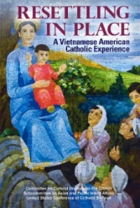
Resettling in Place: A Vietnamese American Catholic Experience

Vietnamese American Catholics are an important part of the Church in the United States. Their story is one conditioned by war, refugee plight, and resettlement. It was their unwavering faith that helped them overcome these obstacles and which continues to bring a new energy to the Church. This book is a snapshot description about a community who rebuilt their faith life by sustaining family values, culture, and Catholic devotional practices.

